PrintSDK 接入文档
- Integrate SDK 集成
1、根目录下的配置文件配置maven地址
Configure Maven address in the configuration file under the root directory
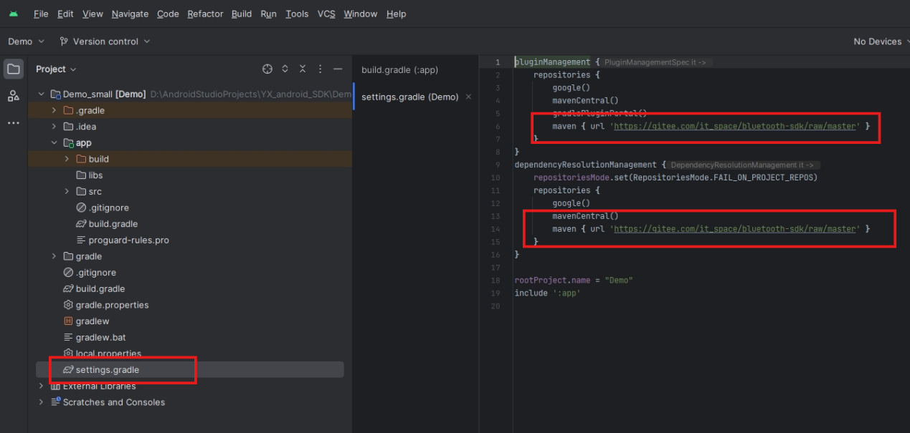
2、app下的build文件配置，添加PrintSDK latest version依赖
Configure the build file in the app and add the PrintSDK latest version dependency
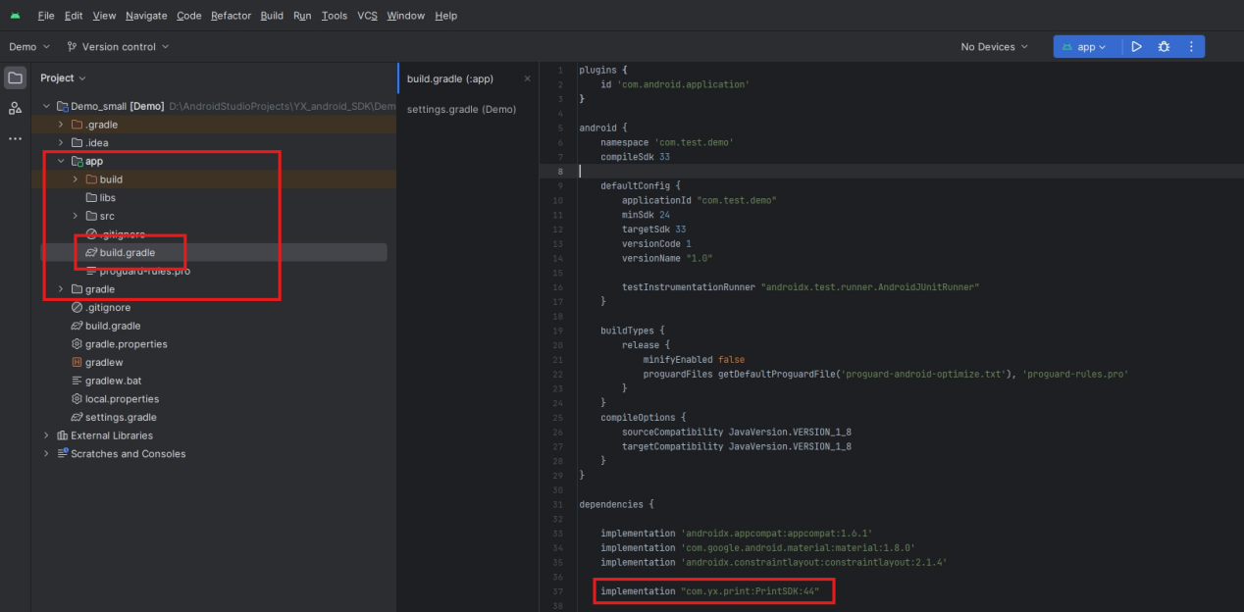
- SDK initialization 初始化
PrinterHelper.intSDK(this,"appkey");
- Manifest参数配置
<uses-permission android:name="android.permission.BLUETOOTH_ADMIN" />
<uses-permission android:name="android.permission.BLUETOOTH" />
<uses-permission android:name="android.permission.ACCESS_COARSE_LOCATION" />
<uses-permission android:name="android.permission.ACCESS_FINE_LOCATION" />
<uses-permission android:name="android.permission.ACCESS_LOCATION_EXTRA_COMMANDS" />
<uses-permission android:name="android.permission.BLUETOOTH_SCAN" />
<uses-permission android:name="android.permission.BLUETOOTH_CONNECT" />
- 扫描蓝牙（这里可以可以SDK的扫描接口，也可以自行处理扫描逻辑，然后调用SDK的DeviceItem.build() 进行初始化）
Scan Bluetooth (you can either use the SDK's scan interface or process the scan logic yourself, and then call the SDK's DeviceItem. build() for initialization)
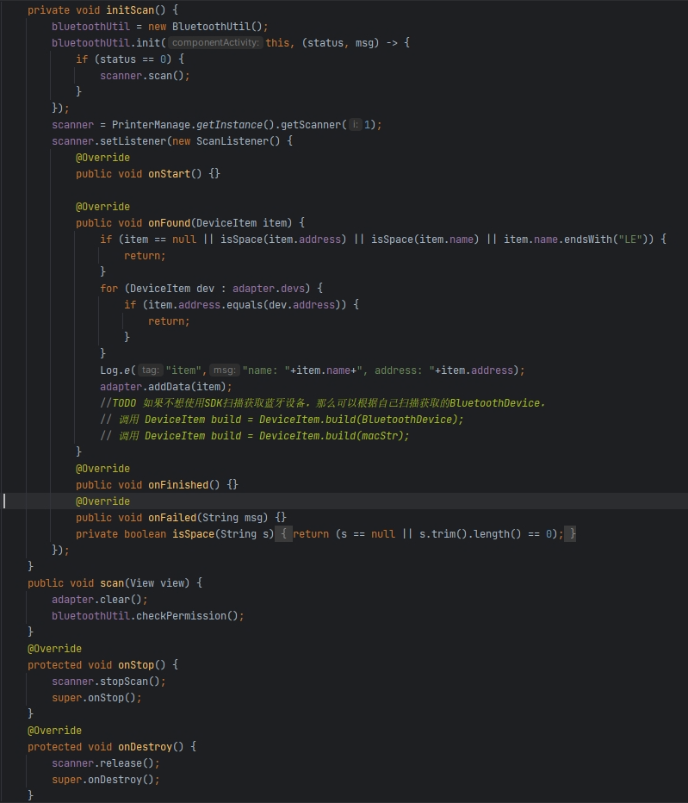

- 连接前初始化
Initialize before connection
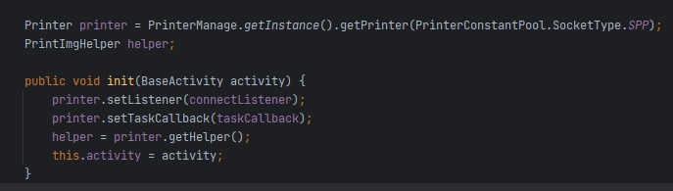
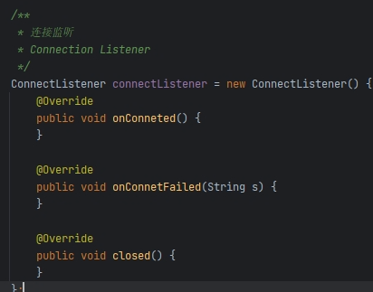
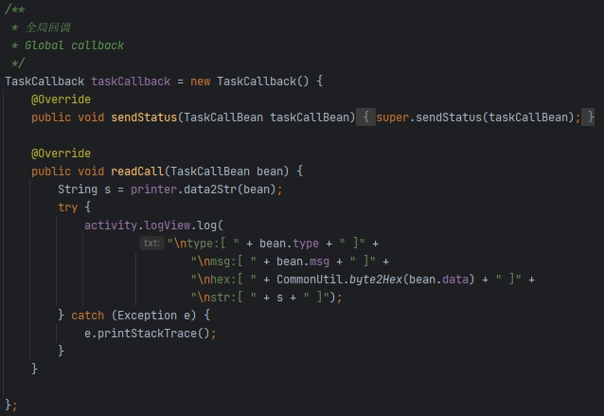
- 连接和断开
Connect and Disconnect
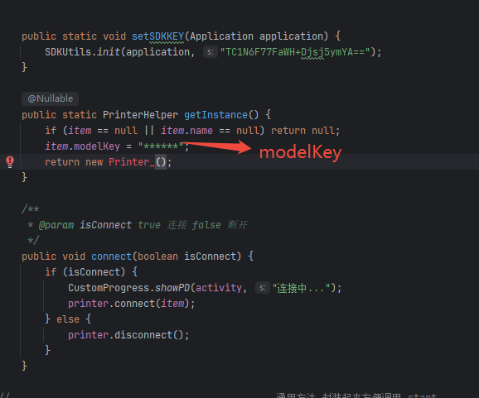
- 添加任务（获取设备信息，设置设备参数以及其它指令）
Add tasks (obtaining device information, setting device parameters, and other instructions)
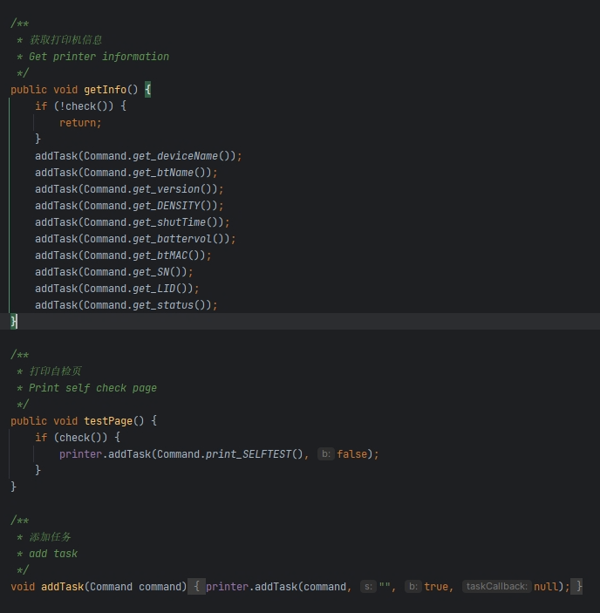
- 获取连接状态 printer.isConnect()
Get connection status printer. isConnect()
- 其他打印功能可以通过demo进行参考，不太系列的打印机，打印逻辑可能会不同，请根据自己需要进行选择
Other printing functions can be referenced through the demo. For printers of different series, the printing logic may be different. Please choose according to your own needs

